Statewide Clinical Network Executive Group
  - Terms of Reference

Background

Statewide Clinical Networks
Statewide Clinical Networks are an important statewide engagement structure to connect clinicians, consumers and other stakeholders on agreed priorities to improve the South Australian health system.
Statewide Clinical Networks are all the health professionals, health service organisations, consumers and carers who work collaboratively with the goal of high quality care in a particular area. Statewide Clinical Networks operate across the continuum of care, across private and public sectors and across all of South Australia (i.e. metropolitan, rural and remote South Australia).
Each of the Statewide Clinical Networks will have an appointed:
- Clinical Lead
- Steering Committee
- Clinical Network Advisor.

Statewide Clinical Network Clinical Leads
Statewide Clinical Network Clinical Leads will commit to:
- The delivery of statewide services and ‘whole of system’ thinking;
- Analysing patient activity trends, service performance, evidence based practice, improving health outcomes for consumers and ensuring the health system provides best value to the community
- Improving health outcomes for Aboriginal and Torres Strait Islander people;
- Strategic leadership outside their own individual service
- Engaging with consumers and clinicians across a range of professions and genders.
Be respected by their clinical peers and demonstrate ability to influence change and improve service delivery.
Support the work of the Data Fellows working on the Clinical Network projects.
Statewide Clinical Network Clinical Leads will also meet as a collective group; the Statewide Clinical Network Executive Group.

Statewide Clinical Network Executive Group

Purpose and aim
The principal purpose / aim of the Statewide Clinical Network Executive Group is to support the Statewide Clinical Networks and their Clinical Leads to achieve what they said they would achieve and develop capability.
This will be achieved by:
- Enabling Clinical Leads to discuss their work in their respective networks, share best practice, and learn and support each other
- Considering Clinical Network synergies, system wide issues and alignment with the SA Health system, and in particular SA Health’s, strategic goals that Statewide Clinical Networks can work on together
- Moving towards more integrated care and reduced silos
- Collaboration and improved communication across and between Clinical Networks, SA Health and Wellbeing SA.

Expected outcomes
The CEIH will provide Clinical Leads with a conduit to key Department for Health Directorates and Wellbeing SA (attached office) and vice versa by holding regular Clinical Network Executive Group meetings (a minimum of 4 per year) to improve communication.
Clinical Leads will have:
- A greater understanding and knowledge of the functions of Department for Health Directorates and Wellbeing SA (an attached office)
- An increased level of clinical empowerment, leadership and involvement in the development and planning of health services across the continuum of care throughout South Australia
- by discussing, reviewing their Clinical Network Work Plans with the Clinical Network Executive Group members.

Accountability and Reporting
The Statewide Clinical Network Executive Group will provide advice to the CEIH Commissioner and its Executive Directors.
The Chair will be an Ex-officio member on the CEIH Clinical Advisory Council (the peak advisory body to the CEIH and the Commissioner).
CEIH Committee Structure
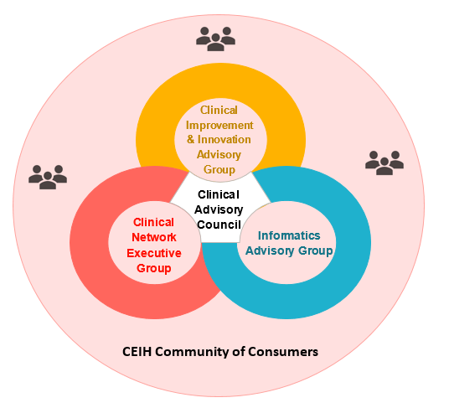
Figure 1 Image of the structure of the CEIH Community of Consumers groups

Membership
Executive Director Consumer and Clinical Partnerships
All Statewide Clinical Network Clinical Leads
Two Consumer Representatives
All SA Health Chief Professional Officers i.e:
- Chief Allied and Scientific Health Officer
- Chief Medical Officer
- Chief Medical Information Officer
- Chief Nursing and Midwifery Officer
- Chief Pharmacist
- Chief Psychiatrist.
One representative nominated by each of the:
- Director, SA Health, Aboriginal Health
- Executive Director, Wellbeing SA (attached office), Integrated Care Systems
- Executive Director, SA Health Safety and Quality
- Executive Director, SA Health, System Design & Planning
- Executive Director, SA Health, Health Services Programs & Funding.
Invitations can be issued for others to be present at one or more meetings as agreed by the Statewide Clinical Network Executive Group.

Chair
The position of Chair and Deputy Chair will be nominated and elected from within the Network Executive Group membership for a term for one year.

Confidentiality
The Statewide Clinical Network Executive Group are expected to adhere to the SA Public Service Code of Ethics and the SA Health Guide to Maintaining Confidentiality in the Public Health System. The SA Health Guide to Maintaining Confidentiality in the Public Health System applies to all SA Health employees, visiting clinicians, contractors, volunteers, trainees and students.

Conflict of interest
Members will declare any real or perceived conflict of interest in writing to the Chair prior to a meeting or verbally at the meeting. For decisions relating to a conflict of interest the Clinical Network Executive Group member will excuse themselves as necessary.

Operating procedures

Meeting frequency
Meeting frequency is at the discretion of the Clinical Network Executive Group, but initially will be monthly for the first three months. It is expected that quarterly meetings are held each year.
All members are welcome to attend via phone or videoconferencing.

Proxies
Members may substitute a proxy for their attendance. If a member is unable to attend 2 meetings in a row, the chair will schedule a meeting with the member to facilitate attendance or discuss alternate membership.

Quorum
A quorum is defined as half the membership plus one.
If the Chair is absent he/she may nominate another member to be chair for that meeting.
If a quorum is not reached, the meeting may still be held and proceedings confirmed at the next meeting where there is a quorum.

Secretariat
The secretariat function will be provided by the CEIH.

Review
These Terms of Reference shall be reviewed initially at 6 months and thereafter annually by the Statewide Clinical Network Executive Group and any proposed revisions forwarded to the CEIH Commissioner for consideration.
Commission on Excellence and Innovation in Health
11 Hindmarsh Square
Adelaide SA 5000
Telephone: 8226 2081
Health.Excellence-Innovation@sa.gov.au
www.ceih.sa.gov.au

